Contents
1. Viewing the Applicant Login page 2
1.1 Viewing the Website 2
1.2 Viewing the Maintenance Form 3
2. Updating the Applicant Login page 6
2.1 Standard message 6
2.2 Downtime message 6
2.3 Closure Periods message 7

Knowledge Article: System Downtimes (not yet written)

Viewing the Search Appointments page

1.1 Viewing the Website

To view the current configuration of the Search Appointments page, go to www.recruit.ox.ac.uk:

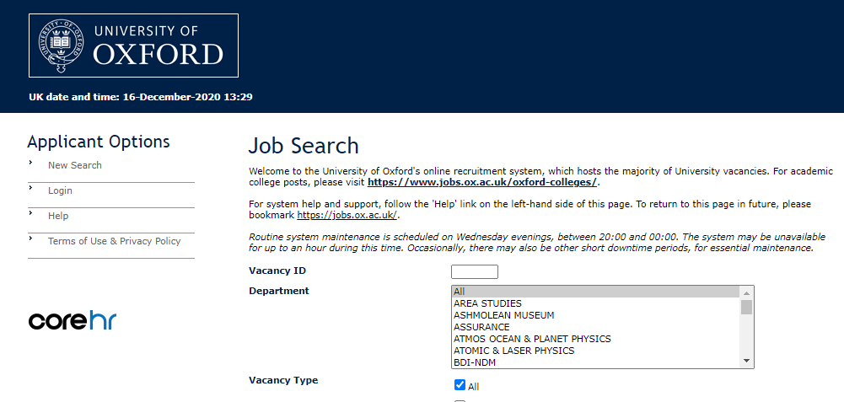

The options, fields, and message(s) visible to job applicants are all configurable:

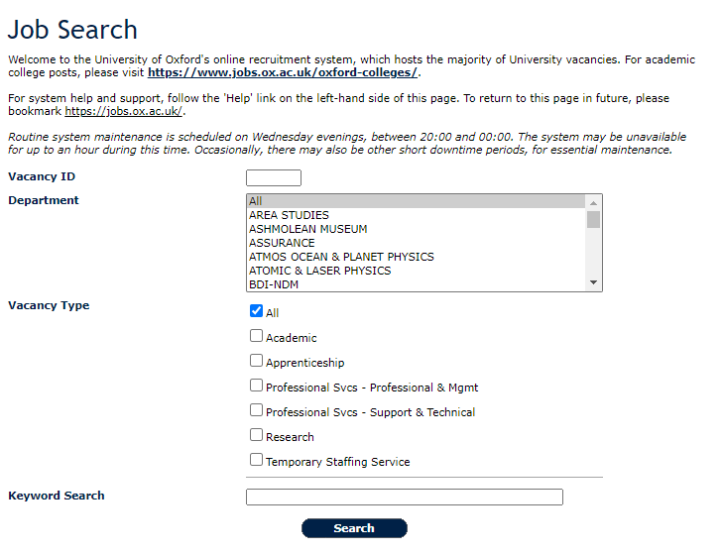

1.2 Viewing the Maintenance Form

To view the options, fields, and message(s) that have been configured for the Search Appointments page, you need to go to the E-Form Maintenance screen.

Portal > Recruitment > Toolbox > Recruitment Admin

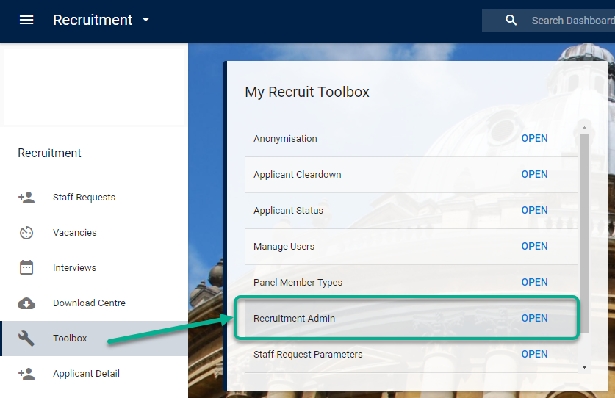

The E-Form Maintenance screen will open. Select “UNIVERSITY OF OXFORD” and “E-Recruitment Form”:

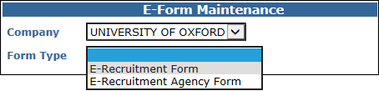

The form will expand to show a number of configurable options. Select “Search Appointments Version 4”:

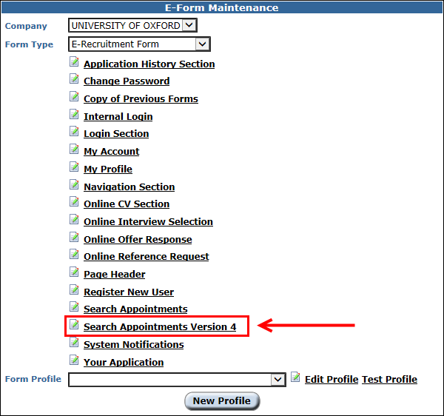

The Search Appointments Version 4 screen will open. Here you can view the items which are visible on the Search Appointments page, including the “Detailed Description”, which is the text which appears on the page at www.recruit.ox.ac.uk.

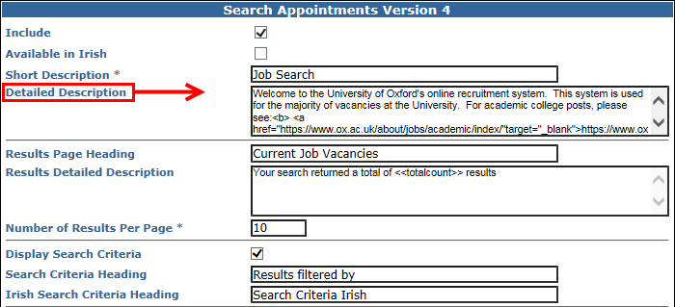

There are many items which can be configured on the Search Appointments page, for both the landing page and the search results page. It is very unlikely you will be asked to update these as part of a system downtime, so do not edit the options selected for each item.

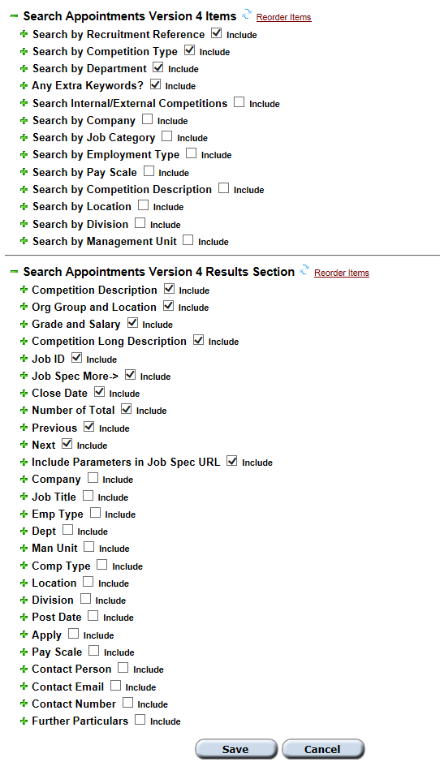

Updating the Search Appointments page

It is sometimes necessary to update the message on the Search Appointments page, for instance, whenever the e-Recruitment system needs to be taken down for maintenance (a “downtime”). You can update this message within the E-Form Maintenance screen.

Portal > Staff Requests > Recruitment > Recruitment Admin

Open the E-Form Maintenance screen and select “Search Appointments Version 4”.

Replace the text in the “Detailed Description” box with the following template texts. You must copy the HTML provided in order to ensure the message displays correctly on the website.

 | NB: Remember to amend the dates, times, and particulars of the message as necessary!

2.1 Standard message

HTML version | Appearance on website
Welcome to the University of Oxford's online recruitment system, which hosts the majority of University vacancies. For academic college posts, please visit <b><a href="https://www.jobs.ox.ac.uk/oxford-colleges/" target="_blank">https://www.jobs.ox.ac.uk/oxford-colleges/</a></b>.<br><br>For system help and support, follow the 'Help' link on the left-hand side of this page. To return to this page in future, please bookmark <u>https://jobs.ox.ac.uk/</u>.<br><br><i><i>Routine system maintenance is scheduled between 20:00 on Wednesdays – 02:00 on Thursdays. The system may be unavailable for up to an hour during this time. Occasionally, there may also be other short downtime periods, for essential maintenance.</i><br> | Welcome to the University of Oxford's online recruitment system, which hosts the majority of University vacancies. For academic college posts, please visit https://www.jobs.ox.ac.uk/oxford-colleges/.  For system help and support, follow the 'Help' link on the left-hand side of this page. To return to this page in future, please bookmark https://jobs.ox.ac.uk/.  Routine system maintenance is scheduled between 20:00 on Wednesdays – 02:00 on Thursdays. The system may be unavailable for up to an hour during this time. Occasionally, there may also be other short downtime periods, for essential maintenance.

2.2 Downtime message

You must edit any text which appears in red before posting the HTML into the “Detailed Description” box.

HTML version | Appearance on website
The University’s e-Recruitment system will be <b>unavailable for use on Tuesday 11 October 2016 between 13:00 and 20:00</b> in order that essential maintenance work can be undertaken. The site will be available again from 20:00 on Tuesday to allow you to access your account and continue to apply for vacancies. We apologise for any inconvenience caused.<br><br> Welcome to the University of Oxford's online recruitment system, which hosts the majority of University vacancies. For academic college posts, please visit <b><a href="https://www.jobs.ox.ac.uk/oxford-colleges/" target="_blank">https://www.jobs.ox.ac.uk/oxford-colleges/</a></b>.<br><br>For system help and support, follow the 'Help' link on the left-hand side of this page. To return to this page in future, please bookmark <u>https://jobs.ox.ac.uk/</u>.<br><br><i><i>Routine system maintenance is scheduled between 20:00 on Wednesdays – 02:00 on Thursdays. The system may be unavailable for up to an hour during this time. Occasionally, there may also be other short downtime periods, for essential maintenance.</i><br> | The University's e-Recruitment system will be unavailable for use on Tuesday 11 October 2016, between 13:00 and 20:00 in order that essential maintenance work can be undertaken. The site will be available again from 20:00 on Tuesday to allow you to access your account and continue to apply for vacancies. We apologise for any inconvenience caused.  Welcome to the University of Oxford's online recruitment system, which hosts the majority of University vacancies. For academic college posts, please visit https://www.jobs.ox.ac.uk/oxford-colleges/.  For system help and support, follow the 'Help' link on the left-hand side of this page. To return to this page in future, please bookmark https://jobs.ox.ac.uk/.  Routine system maintenance is scheduled between 20:00 on Wednesdays – 02:00 on Thursdays. The system may be unavailable for up to an hour during this time. Occasionally, there may also be other short downtime periods, for essential maintenance.

2.3 Closure Periods message

You must edit any text which appears in red before posting the HTML into the “Detailed Description” box.

HTML version | Appearance on website
<table style="background-color: #ffffe6; border: solid 1px #000000; padding : 2px; width: 100%;"><tr><td style="text-align: center; color: #000000; font-family: verdana,tahoma,arial, sans-serif; font-size: 8pt; background-color : #FFFFFF; font-weight: normal; font-style: normal; padding-bottom : 4px; background-color: #ffffe6; width: 90%;">Please note that the helpdesk will be closed from <b>4pm on Friday 18 December 2020 until 8.30am on Monday 4 January 2021</b>. We will respond to any requests for technical assistance over this period as soon as possible on our return. In the meantime, please check our <a href="https://staff.admin.ox.ac.uk/recruitment-support-faqs" target="_blank">help page</a> which may answer your query. </td></tr></table><br>Welcome to the University of Oxford's online recruitment system, which hosts the majority of University vacancies. For academic college posts, please visit <b><a href="https://www.jobs.ox.ac.uk/oxford-colleges/" target="_blank">https://www.jobs.ox.ac.uk/oxford-colleges/</a></b>.<br><br>For system help and support, follow the 'Help' link on the left-hand side of this page. To return to this page in future, please bookmark <u>https://jobs.ox.ac.uk/</u>.<br><br><i><i>Routine system maintenance is scheduled between 20:00 on Wednesdays – 02:00 on Thursdays. The system may be unavailable for up to an hour during this time. Occasionally, there may also be other short downtime periods, for essential maintenance.</i><br> |  | Please note that the helpdesk will be closed from 4pm on Friday 18 December 2020 until 8.30am on Monday 4 January 2021. We will respond to any requests for technical assistance over this period as soon as possible on our return. In the meantime, please check our help page which may answer your query.  Welcome to the University of Oxford's online recruitment system, which hosts the majority of University vacancies. For academic college posts, please visit https://www.jobs.ox.ac.uk/oxford-colleges/.  For system help and support, follow the 'Help' link on the left-hand side of this page. To return to this page in future, please bookmark https://jobs.ox.ac.uk/.  Routine system maintenance is scheduled between 20:00 on Wednesdays – 02:00 on Thursdays. The system may be unavailable for up to an hour during this time. Occasionally, there may also be other short downtime periods, for essential maintenance.

2.4 Editing the message

To change the message displayed on the Search Appointments page, you must overwrite the text in the “Detailed Description” box with the HTML from the appropriate message-template given above. Remember to edit your template with the relevant times, dates, and details.

NB: If your message does not conform to one of the templates given above, you must ensure that you have properly HTML-tagged the text or it will not display correctly on the website.

When you are done, click “Save” at the bottom of the page:

